Open Society Justice Initiative - NUI Galway - Centre for European Law - Professional Seminars
A new approach to personal debt litigation: The role of the Unfair Contract Terms Directive and the Charter of Fundamental Rights
Dr Padraic Kenna NUI Galway

Introduction.

In this short paper, designed as a background briefing to the professional seminars on abusive lending and human rights, I will address the EU Charter of Fundamental Rights. Firstly, a brief overview of the status of the Charter reveals that has been part of Treaty law since 2009. However, awareness of its existence among the European and Irish public and legal profession is patchy. References to the Charter in the decisions of the Irish Superior Courts has declined since 2012. Next, I consider the much debated question of the scope of application of the Charter, especially how it relates to national laws. Thirdly, I examine how the Charter can be interpreted, and the quite innovative way it brings a catalogue of international human rights instruments within binding EU law. Fourthly, I consider some examples where the Charter has informed the interpretation of other EU law, particularly the Unfair Contract Terms Directive (UCTD). This demonstates, somewhat, the potential for the Charter to have a more significant role in the development of Irish law on debt-related proceedings. Finally, there is a list of Charter Articles.

1. Overview of Charter and status.

The EU Charter of Fundamental Rights (Charter) is set to develop significant standards for Irish law. Since the end of 2009 this EU bill of rights is binding on EU institutions and on Member States when they are implementing or acting within the scope of EU law. In 2015, the European Parliament stressed that “national authorities (judicial authorities, law enforcement bodies and administrations) are key actors in giving concrete effect to the rights and freedoms enshrined in the Charter”…. Legal practitioners, particularly,have to be familiar with Charter rights if these are to be implemented in practice. In June 2015, the Council of the European Union noted that it is “necessary to continue promoting training and best practice sharing in the field of judiciary at national and EU level thus enhancing mutual trust”.

The original Charter was ‘jointly and solemnly proclaimed’ at Nice in 2000. It was then modified and in 2007, now with 54 rights, was incorporated into EU Treaty law in Article 6 TFEU:

“1. The Union recognises the rights, freedoms and principles set out in the Charter of Fundamental Rights of the European Union of 7 December 2000, as adapted at Strasbourg, on 12 December 2007, which shall have the same legal value as the Treaties. The provisions of the Charter shall not extend in any way the competences of the Union as defined in the Treaties. The rights, freedoms and principles in the Charter shall be interpreted in accordance with the general provisions in Title VII of the Charter governing its interpretation and application and with due regard to the Explanations referred to in the Charter, that set out the sources of those provisions…

A significant addition to the Charter are the The Explanations relating to the Charter of Fundamental Rights (Explanations), described in Article 52(7): “The Explanations drawn up as a way of providing guidance in the interpretation of this Charter shall be given due regard by the courts of the Union and of the Member States.”

The European Agency for Fundamental Rights (FRA) promotes the Charter and its Charterpedia is an online tool which provides easy-to-access information about that encompassing fundamental rights framework. It includes the full text and legal Explanations of the Charter articles, related EU and national case law, and related FRA publications, provided on an article-by-article basis. To ensure the implementation of fundamental rights and freedoms enshrined in the Charter, the European Commission has published, since 2010, an Annual Report on the application of the Charter. This provides examples of how the Charter was applied in and by Member States when implementing Union law, and presents main case law developments. There has been a growing number of references for a preliminary ruling to the CJEU involving Charter Articles. This growing trend in the relevance of the Charter within national and EU law is set to continue.
2. Context –awareness of the Charter

The Charter became part of binding EU law in 2009, yet familiarity with its provisions or impact remains relatively weak. The European Commission, in Spring 2015, conducted an EU-wide survey of 26,500 citizens, which revealed that while general awareness of the Charter remained rather high, actual knowledge of it remained low. Over a third of respondents had never heard of the Charter. This survey also found that precise knowledge of when the Charter does and does not apply is still low. Ireland ranks poorly among the Member States in relation to responses on the question of familiarity with the Charter. The following chart shows the results of that survey and Eurobarometer Report. It shows familiarity with the Charter in Ireland at 8%, although up from 5% in 2012. The EU28 average was 14% in 2015 (up from 11%).

European Commission survey (2015) on Charter

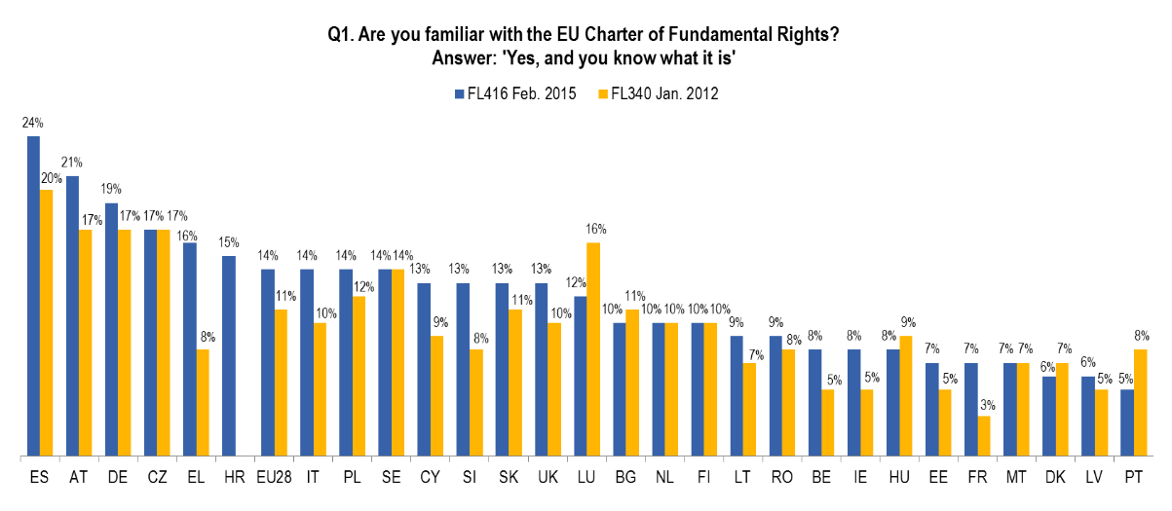

The greatest confusion rests around whether the Charter applies to all actions of Member States, including matters of national competence. In relation to the question “The Charter applies to all actions of EU Member States, including on matters of
national competence,” Romania (72%) has the highest proportion of respondents who say, wrongly, that the statement is true, followed by Croatia, Ireland and Latvia (all 66%).
Correct answers to the question “The Charter applies to EU Member States only when they implement EU law” ranged from 75% in Bulgaria and 72% in Romania, to 51% in Italy and 52% in Malta. Ireland had a 60% correct answer rate, but also a 32% incorrect answer rate.
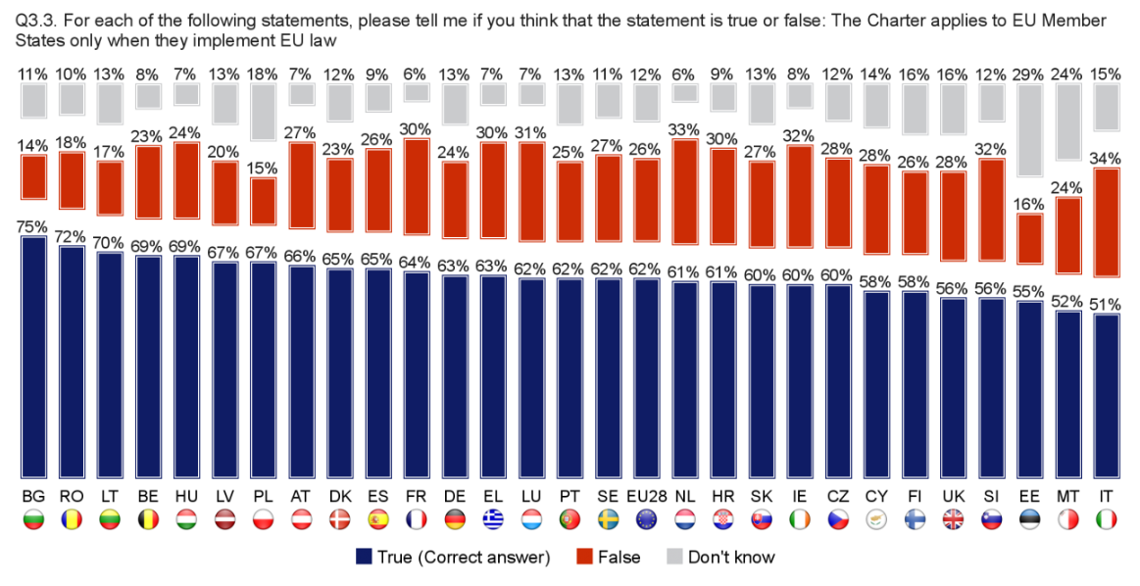

In 13 of the 28 EU Member States respondents were most likely to turn to a court in their country if their Charter rights were violated. In six Member States they were most likely to an EU institution. In seven Member States, respondents were most likely to turn to a national ombudsman or independent body, and in the remaining two Member States –Belgium and Sweden –a majority of respondents would turn to the national police.

Significantly, Ireland had the lowest proportion of respondents who would turn to a court for a remedy for Charter violations (29% as compared to an EU average of 43%).
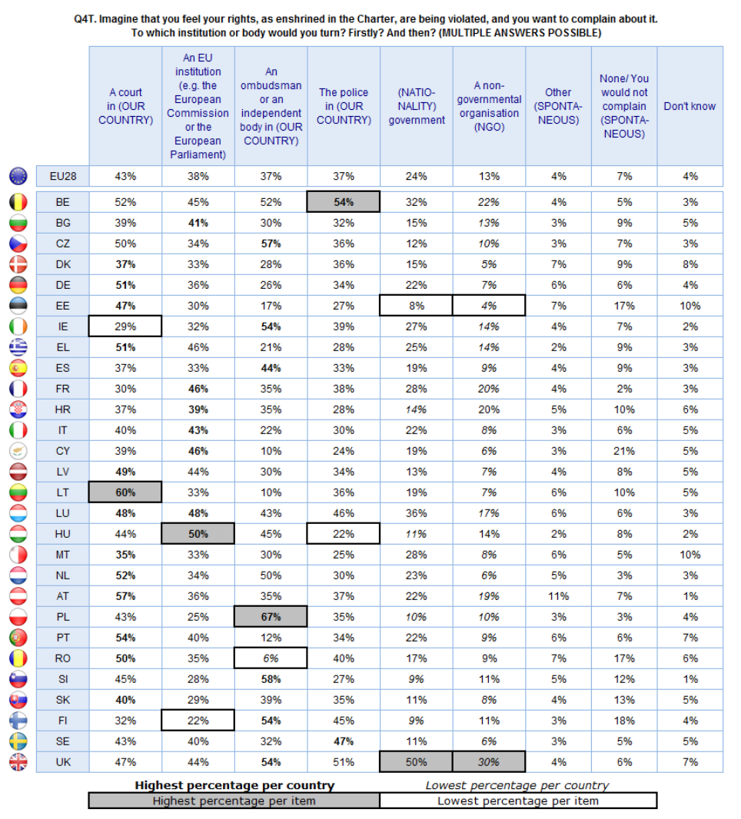

National courts in all EU Member States parties can invoke the Charter at their own inititiave - judges can invoke it of their own motion. In 2015, FRA examined 68 national court decisions in 26 EU Member States (three per Member State). This study found that in one third of cases it was national judge, on their own initiative, who first invoked the Charter.

The main areas where the Charter was invoked in national courts were: Article 47, on the right to an effective remedy and fair trial; Article 7, respect for privacy and family life; Article 8 protection of personal data; Article 51 and 52 on field of application and scope of guaranteed rights.

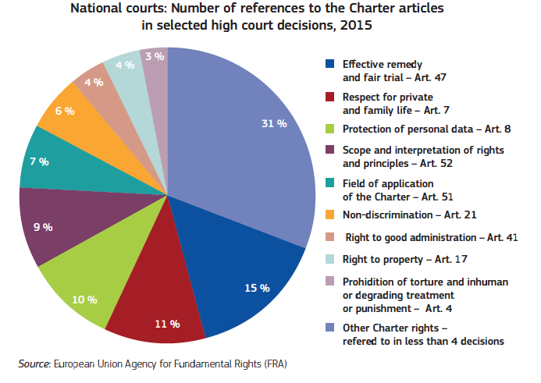

The following Figure from that FRA 2015 study shows the actual numbers of references to Charter Articles in the sample of 68 national cases examined.

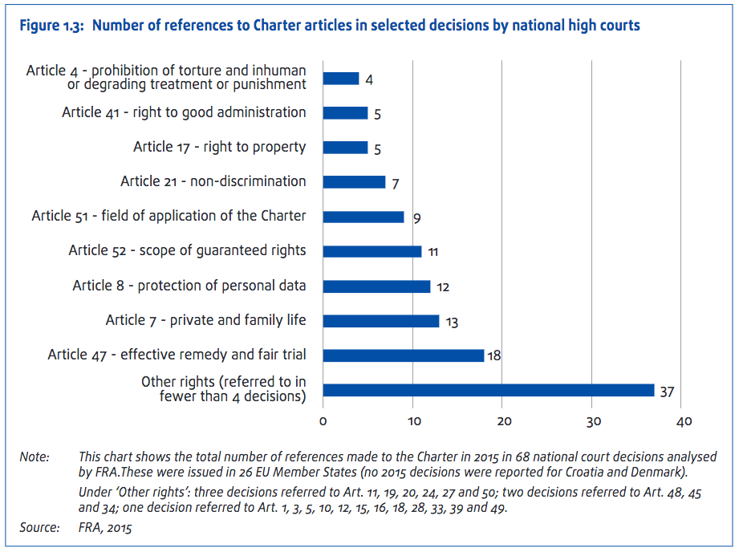

According to FRA, the question of whether – and why – the Charter applies is rarely addressed in detail by national judges.

“Just as in previous years, courts often relied on the Charter without explaining whether, or why, the Charter legally applies. However, it would be beneficial for national courts to apply a systematic ‘Article 51 screening’. This could help ensure that the Charter is referred to in all cases in which it has the potential to add value; it would also increase awareness of the Charter among the national judiciary and serve legal certainty.”

In Ireland , there are many references to the Charter in the judgments of the Superior Courts, since 2009, as shown in the following Chart.

References to the EU Charter of Fundamental Rights in Irish Superior Court judgments, 2005-2014

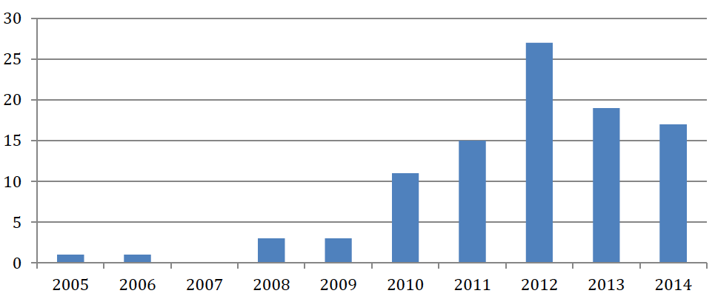

Clearly, understanding the scope and application of the Charter is a key area to be developed for integrating the Charter into Irish law.

3. The Application and Scope of the Charter

- Overview

The EU Charter of Fundamental Rights was given “the same legal value as the Treaties” in Article 6 TEU. This gives the Charter a higher normative status than EU legislation and national laws implementing EU law. It operates within the base of EU law, but, significantly, it brings together in a single document all the rights found in the case law of the CJEU; the rights and freedoms enshrined in the ECHR; other rights and principles resulting from the common constitutional traditions of EU countries and other international (including Council of Europe and UN instruments). The Charter contains rights and freedoms under six titles: Dignity, Freedoms, Equality, Solidarity, Citizens' Rights, and Justice. The Charter is consistent with the European Convention on Human Rights of the Council of Europe, and when it contains rights that stem from this Convention, their meaning and scope are the same.

Article 51(1) of the Charter stipulates that:

The provisions of this Charter are addressed to the institutions, bodies, offices and agencies of the Union with due regard for the principle of subsidiarity and to the Member States only when they are implementing Union law. They shall therefore respect the rights, observe the principles and promote the application thereof in accordance with their respective powers and respecting the limits of the powers of the Union as conferred on it in the Treaties.

Article 51 states that the Charter is binding on (i) the institutions, bodies, agencies and offices of the EU, and (ii) Member States when they are implementing EU law, although the term “acting in the scope of EU law” is used in the Explanations on Article 51. Of course, the converse is also that where a legal situation does not fall within the scope of Union law, the Court has no jurisdiction to rule on it and any Charter provisions relied upon cannot, in itself, form the basis for such jurisdiction.

Article 51(2) points out that the Charter does not extend the field of application of Union law beyond the powers of the Union or establish any new power or task for the Union, or modify powers and tasks as defined in the Treaties.

Essentially, the Charter ‘shadows’ existing EU law provisions, so that whenever an issue of EU law is being adjudicated, then the Articles of the Charter must be also applied. The Explanations confirm that Article 51(1) “was not intended as any dramatic change in the scope of application of EU human rights law, but rather followed “unambiguously” from the CJEU’s pre-existing case law.”

In all cases, EU Member States are under an obligation to interpret national law harmoniously, i.e. in a way that will not conflict with the EU act (called indirect effect and stemming from the principle of sincere cooperation). Under the doctrine of consistent interpretation, national courts and administrations have a duty to interpret national law in light of EU law. Individuals can obtain damages, in specific circumstances, where a breach of EU law has been established.

Under the principle of derogation, in Article 52(1), Member States may limit the application of the rights in the Charter as long as the limitation is (i) provided for by law, (ii) respects the essence of the rights in the Charter, and (iii) is subject to the principle of proportionality – meaning that the limiting measure is necessary, and genuinely meets the EU’s objectives of general interests or the need to protect the rights and freedoms of others. However, Article 53 prevents the Charter being used to reduce or lower any existing human rights applicable. The relevant EU regulations, directives or national laws implementing these are read through the prism of the Charter Articles, which have links to other instruments.

b. Compatibility of the domestic provision with the Charter

The Articles of the Charter apply if a domestic measure falls under the ‘scope of EU law’. There are three scenarios where this is most likely to occur.

(i) The action of the Member States is “entirely determined by EU law.”

In this scenario, the national measure implements EU measures (or a provision therein) that already determine the exact level of protection that must be granted to the fundamental right(s) involved. This can involve national measures adopted to implement EU primary law, an EU Regulation, or an EU Directive. It can also include national measures which substantially act as implementing measures, though not specifically adopted on that purpose (Member States do not need to pass specific measures in order to implement a Directive if the domestic legal order is already in conformity with that Directive), or national measures which in any event have the effect to implement an obligation of the Member States under EU law, even if adopted before the EU provision that places the specific obligation on Member States (e.g. the obligation to adopt sanctions aimed to ensure the effective collection of VAT: Fransson).

Clearly, the EU measure must comply with the Charter. Therefore, if the national judge considers that the standard of protection endorsed by the EU measure does not comply with the Charter, they can question the validity of the EU measure through the preliminary reference to the CJEU. In particular, a national judge that doubts the validity of the EU measure/provision cannot set it aside without a preliminary reference to the CJEU, even when the judge a quo is not a last instance court. By contrast, if the validity of the EU measure is not in question, the national judge must ensure that the domestic provision is in line with the level of protection established by the EU measure/provision. If it lowers that level of protection, the domestic measure is not compatible with the Charter.

(ii) The action of the Member States is “not entirely determined by EU law”

In this scenario, the domestic provision is connected with a EU measure that leaves to the Member States to determine the level of fundamental rights protection (e.g., national provisions of procedural law governing the exercise of (ordinary) rights conferred by EU law before domestic courts, or national provisions laying down sanctions aimed to ensure that the objectives pursued/rights conferred by a EU measure are adequately achieved/protected. In these cases, the Member States (including judges) must ensure that the domestic measure complies with the Charter or, (which is the same), provides for restriction to the fundamental rights therein that satisfy the test of proportionality laid down by Article 52(1) of the Charter. Unlike in the previous scenario, Member States can decide to enhance the level of protection established by the Charter (for instance, because the domestic Constitution grants broader protection to the fundamental right(s) involved). However, the EU measure must still be complied with and competing fundamental rights must not be unjustifiably restricted.

Article 19(1) TEU provides that ‘Member States shall provide remedies sufficient to ensure effective legal protection in the fields covered by Union law’. In relation to national sanctions for violation of EU rights, the two fundamental principles of EU law: equivalence and effectiveness become central. The principles of equivalence requires national judges to set aside national procedural rules which establish more disadvantageous conditions for the exercise of rights derived from EU law, compared with equivalent rights granted by national law; under the principle of effectiveness, national procedural provisions must not make it impossible or excessively difficult to protect (also ordinary) rights granted by EU law. The impossible or excessively difficult character of a national procedural rules is established “by reference to the role of that provision in the procedure, its progress and its special features, viewed as a whole, before the various national instances.”

As regards the principle of effectiveness, it is the Court’s settled case-law that every case in which the question arises as to whether a national procedural provision makes the application of European Union law impossible or excessively difficult must be analysed by reference to the role of that provision in the procedure, its progress and its special features, viewed as a whole, before the various national bodies (see Banco Español de Crédito, paragraph 49).

(iii) Member States seek to implement a legitimate derogation from EU law

The significance of the ERT case is that EU Member States are obliged to respect fundamental rights whenever they adopt measures derogating from EU law or when they rely on derogations from fundamental Treaty rules. Domestic measures implementing derogations provided by EU primary or secondary law must be proportionate: they must strike a fair balance between their (legitimate) purpose pursued and the non-application of the EU law rule. All national measures derogating from EU law must respect the Charter. Therefore, any restriction to the fundamental rights granted therein in view of a legitimate interest must satisfy the test of proportionality of Article 52(1) of the Charter.

(iv) Some recent decisions

This delineation on when States are acting within EU law, or not, and whether concurrently bound by the Charter is leading to much case law. In Fransson the CJEU interpreted the application of EU law and the Charter as meaning that “the fundamental rights granted by the Charter must be complied with where national legislation falls within the scope of European Union law.” In that case, the CJEU held that the Swedish rules on penalties and criminal proceedings for breach of tax law should be evaluated for compliance with the Charter. The CJEU observed that the national (Swedish) measure was connected (in part) to infringements of the EU VAT Directive, and therefore was designed to implement an obligation imposed on the Member States by EU law “to impose effective penalties for conduct prejudicial to the financial interests of the European Union”. Thus, the CJEU held that national measures, which were connected in part to a specific obligation imposed by EU law on the Member State, fell within the scope of application of EU law, and therefore the Charter was engaged. In this case the Swedish law was in place before the EU law.

In other recent judgments the CJEU pointed out that the concept of ‘implementation’ of EU law in Article 51 of the Charter requires a certain degree of connection with EU law. Indeed, the CJEU seems to be distilling national measures into the parts which correspond with EU law, and the parts which do not – the latter not coming “within the scope” of EU law.

The question as to whether national legislation implements EU law was considered in Julian Hernandez [2014], where the CJEU held that in order for national legislation to be regarded as implementing EU law, within the meaning of Article 51 Charter, there must be a connection between a measure of EU law and the national measure at issue, which goes beyond the matters covered being closely related, or one of those matters having an indirect impact on the other.

The mere fact that a national measure comes within an area in which the EU has powers cannot bring it within the scope of EU law and, therefore, render the Charter applicable. Thus, in order to determine whether a national measure involves the implementation of EU law, it is necessary to determine, inter alia, whether the national legislation at issue is intended to implement a provision of EU law; the nature of that legislation and whether it pursues objectives other than those covered by EU law, even if it is capable of directly affecting EU law; and, lastly, whether there are specific rules of EU law on the matter or rules which are capable of affecting it. In this case the CJEU held that a provision of national law, which merely grants employees more favourable protection resulting from the exercise of the exclusive competence of the Member States, confirmed by the first paragraph of Article 11 of Directive 2008/94, cannot be regarded as coming within the scope of that directive.

The European Commission has produced, A user-friendly tool to detect violations falling within the scope of the EU Charter of Fundamental Rights - Don't knock on the wrong door: CharterClick!

4. Interpretation of the Charter - key Articles and links to other human rights instruments

One of the unique features of the Charter is how it inserts the catalogue of international human rights, from the Council of Europe and the UN, into the framework of binding EU law, once the Charter is engaged.

Article 52(3) states that:

Insofar as this Charter contains rights, which correspond to rights guaranteed by the Convention for the Protection of Human Rights and Fundamental Freedoms, the meaning and scope of those rights shall be the same as those laid down by the said Convention. This provision shall not prevent Union law providing more extensive protection.

The level of protection afforded by the Charter may never be lower than that guaranteed by the ECHR in a specified area.

The Explanations provide a list of Charter Articles which correspond (totally or partially) with ECHR Articles and other human rights provisions. Since the ECHR jurisprudence is developing separately, the Explanations are critical for maintaining the interactive link with Charter Articles. Thus, many hitherto non-binding human rights protections can now become part of binding EU law. Once the Charter is engaged or triggered by the application of an (non Charter) EU law rule, the jurisprudence of the Charter and its corresponding ECHR rights becomes active. This opens up a valuable source of jurisprudence for EU law. However, to date, this has only been lightly developed in debt-related areas, principally in relation to Charter Articles 7, 38 and 47.

A more detailed outline of these interactive Charter Articles shows the potential for development of Charter-based human rights protection.

Article 4 of the Charter which states that “No one shall be subjected to torture or to inhuman or degrading treatment or punishment,” corresponds with Article 3 of the ECHR. A number of housing obligations have been interpreted as arising from Article 3 ECHR. This has been held to create a positive obligation on States to ensure that a minimum level of shelter and other assistance is available to everyone in the territory of the State.

Article 7 of the Charter which states that “Everyone has the right to respect for his or her private and family life, home and communications,” corresponds with Article 8 of the ECHR. Consequently, the protections created by this Article are the same as those already accepted by the European Court of Human Rights (ECtHR) for Article 8 ECHR. The Convention case-law is clear on the point that the concept of “home” within the meaning of Article 8 is not limited to those premises which are lawfully occupied or which have been lawfully established. “Home” is an autonomous concept, which does not depend on classification under domestic law.

Whether or not a particular premises constitutes a “home” which attracts the protection of Article 8 § 1 will depend on the factual circumstances, namely, the existence of sufficient and continuous links with a specific place (see Buckley v. the United Kingdom, 25 September 1996, Reports 1996-IV, §§ 52-54, and Commission’s report of 11 January 1995, § 63; Gillow v. the United Kingdom, 24 November 1986, § 46, Series A no. 109; Wiggins v. the United Kingdom, no. 7456/76, Commission decision of 8 February 1978, DR 13, p. 40; and Prokopovich v. Russia, no. 58255/00, § 36, ECHR 2004‑XI (extracts)). Thus, whether a property is to be classified as a “home” is a question of fact and does not depend on the lawfulness of the occupation under domestic law (see McCann v. the United Kingdom, no. 19009/04, § 46, 13 May 2008).

The developing ECtHR jurisprudence on Article 8 in relation to homes and accommodation rights has led to significant standards and positive obligations being prescribed in relation to procedural and substantive obligations on eviction from ‘home’ and repossession proceedings by landlords and lenders. In McCann v UK, the ECtHR reiterated the protections of Article 8 ECHR, and this is considered below in the final section of this paper:

The loss of one’s home is a most extreme form of interference with the right to respect for the home. Any person at risk of an interference of this magnitude should in principle be able to have the proportionality of the measure determined by an independent tribunal in the light of the relevant principles under Article 8 of the Convention, notwithstanding that, under domestic law, his right of occupation has come to an end.

Article 17 of the Charter on the right to property includes similar (though not identical) wording to Article 1 of Protocol 1 of the ECHR:

Everyone has the right to own, use, dispose of and bequeath his or her lawfully acquired possessions. No one may be deprived of his or her possessions, except in the public interest and in the cases and under the conditions provided for by law, subject to fair compensation being paid in good time for their loss. The use of property may be regulated by law in so far as is necessary for the general interest.

The Explanations point out that “the meaning and scope of the right are the same as those of the right guaranteed by the ECHR and the limitations may not exceed those provided for there.” The ECtHR jurisprudence on Article 1 of Protocol 1 has held that social assistance entitlements can be regarded as ‘possessions’, and where there is a delay in implementing these rights, then a breach of Article 1 of Protocol 1 can take place. In the ECtHR case of Bäck v Finland, a creditor argued that legislation which allowed a court to adjust or write off the debt (subject to conditions) and suspend possession proceedings, violated his right to property under Article 1 of Protocol 1 to the ECHR. This legislation allowed the local Finnish district court to reduce or irrevocably extinguish the debt. The applicant argued, moreover, that while the adjustment of the debts may have saved the borrower from “social misery”, at the same time similar misery was created for creditors. However, the ECtHR held that there was no violation, as the measure was justified by a legitimate aim in the general public interest. This was not nullified by the fact that the community at large were not the beneficiaries.

Article 21 of the Charter prohibits discrimination on grounds of sex, race, colour, ethnic or social origin, genetic features, language, religion or belief, political or other opinion, membership of a national minority, property, birth, disability, age or sexual orientation.

Article 24(1) on the rights of the child provides that: “Children shall have the right to such protection and care as is necessary for their well-being. They may express their views freely. Such views shall be taken into consideration on matters which concern them in accordance with their age and maturity.” The Explanations point out that this Article is based on the UN Convention on the Rights of the Child (1989). Ireland ratified the United Nations Convention on the Rights of the Child in 1992. The Convention outlines in detail the standards that apply to the needs of children, and binds States to adhere to these standards. The Convention is informed by four core principles: non-discrimination; the best interests of the child; the right to life, survival and development and respect for the views of the child. The UN Committee on the Rights of the Child published its Concluding observations on the combined third and fourth periodic reports of Ireland in February 2016, with a number of relevant recommendations:

In the light of its general comment No 14 (2013) on the right of the child to have his or her best interests taken as a primary consideration, the Committee recommends that the State party strengthen its efforts to ensure that this right is appropriately integrated and consistently interpreted and applied in all legislative, administrative and judicial proceedings and decisions as well as in all policies, programmes and projects that are relevant to and have an impact on children. In this regard, the State party is encouraged to develop procedures and criteria to provide guidance to all relevant persons in authority for determining the best interests of the child in every area and for giving it due weight as a primary consideration.

In relation to the rights of children to an adequate standard of living:

The Committee is deeply concerned at reports of families affected by homelessness facing significant delays in accessing social housing and frequently living in inappropriate, temporary or emergency accommodation on a long-term basis.
The Committee urges the State party to undertake measures to increase the availability of social housing and emergency housing support. In doing so, the State party should ensure that the housing and support provided through those measures are appropriate to the needs of the children affected and subject to adequate safeguards, reviews and evaluations.

Article 26 of the Charter on the integration of persons with disabilities sets out obligations to recognize and respect the rights of persons with disabilities to benefit from measures designed to ensure their independence, social and occupational integration and participation in the life of the community. The Explanations state that this Article is based on Article 15 of the European Social Charter. The EU concluded the UN Convention on the Rights of Persons with Disabilities and the Optional Protocol in 2011, and it has been signed and ratified by almost all (except Ireland), creating a range of non-discrimination obligations, and promotion of independent living, for persons with disabilities. According to Article 216(2) TFEU, agreements concluded by the Union are binding on its institutions and its Member States.

Article 33(1) of the Charter states in identical wording to Article 16 of the European Social Charter (ESC) that: “The family shall enjoy legal, economic and social protection”. Thus, Article 33 of the Charter obligations, once engaged, are the same as Article 16 ESC where “states must promote the provision of an adequate supply of housing for families, take the needs of families into account in housing policies and ensure that existing housing be of an adequate standard and include essential services (such as heating and electricity)….adequate housing refers not only to a dwelling which must not be sub-standard and must have essential amenities, but also to a dwelling of suitable size considering the composition of the family in residence. This Article and its associated provisions could be applied to protect family members who act as consumer credit guarantors for a relative, if they have received misleading information by a financial institution.

While there is not a specifically enforceable right to housing in the Charter, Article 34(3) on social security and social assistance states:

In order to combat social exclusion and poverty, the Union recognises and respects the right to social and housing assistance so as to ensure a decent existence for all those who lack sufficient resources, in accordance with the rules laid down by Union law and national laws and practices.

The Explanations state that paragraph 34(3) of the Charter “draws on Article 13 of the European Social Charter and Articles 30 and 31 of the revised Social Charter and point 10 of the Community Charter.” Clearly, the interpretation of Article 34(3) will draw on the jurisprudence of the Council of Europe European Committee of Social Rights (ECSR) and there is a corpus of jurisprudence from the ECSR through its Conclusions and its Decisions on Collective Complaints. However, the Explanations state that the Union must respect Article 34(3) “in the context of policies based on Article 153 of the Treaty on the Functioning of the European Union.” Article 153 (ex Article 137 TEC) provides that the Union shall support and complement the activities of the Member States in the fields including the combating of social exclusion. Thus, in Morcillo (no. 2) Article 34(3) was held not to provide individually enforceable rights to housing in the context of eviction-related proceedings.

However, the CJEU has pointed out that, when determining social security, social assistance and social protection measures defined by national law and subject to equal treatment under EU law, Member States must “comply with the rights and principles provided for under the Charter including those laid down under Article 34 thereof.”

Article 47 of the Charter on the right to an effective remedy and to a fair trial states:

Everyone whose rights and freedoms guaranteed by the law of the Union are violated has the right to an effective remedy before a tribunal in compliance with the conditions laid down in this Article.
Everyone is entitled to a fair and public hearing within a reasonable time by an independent and impartial tribunal previously established by law.
Everyone shall have the possibility of being advised, defended and represented.
Legal aid shall be made available to those who lack sufficient resources in so far as such aid is necessary to ensure effective access to justice.

The Explanations state the second paragraph of Article 47 corresponds with Article 6(1) ECHR, and therefore the relevant ECtHR jurisprudence applies to the interpretation of obligations in EU law where the Charter is engaged. The Explanations also provide that:

With regard to the third paragraph, it should be noted that in accordance with the case-law of the European Court of Human Rights, provision should be made for legal aid where the absence of such aid would make it impossible to ensure an effective remedy (ECHR judgment of 9 October 1979, Airey, Series A, Volume 32, p. 11).

Clearly, this creates a more binding set of human rights protections arising from the incorporation of ECHR norms into EU law.

Commentators suggest that provided there is an EU competence involved in the disputed legal issue (whether exclusive or shared), EU fundamental rights should protect the citizen of the EU, even if such competence has not yet been exercised.

Summary of Charter links with other human rights

Table 1. Links between Charter Articles and Articles in other Human Rights Instruments.

Charter | Where meaning and scope same as ECHR/(R)ESC Article
Article 7 | Corresponds to Art 8 ECHR – respect for home, privacy and family life – many cases in this area ‘proportionality’ of a possession order
Article 17 | Corresponds to Art 1 of Protocol 1 ECHR right to peaceful enjoyment of possessions (small difference in wording) - many cases
Article 20 | Non discrimination by EU institutions or Member States when implementing EU law
Article 24 | Rights of the child – ‘right to such protection and care as is necessary for their well-being’ – ‘best interests of the child’ CRC]
Article 25 | Rights of the elderly– based on Art 23 ESC
Article 26 | Integration of persons with disabilities – based on Art 15 ESC [enabling access to … housing…] Note - UN Convention on Rights of Persons with Disabilities ratified by EU – now part of EU law.
Article 33 | Corresponds with Art 16 ESC on rights of the family to social, legal and economic protection. The ECSR has much case law on this.
Article 34(2) | Corresponds to Arts 12(4) and 13(4) ESC [right to social security and right to social and medical assistance]
Article 34(3) | Corresponds to Arts 13 ESC and Arts 30 and 31 RESC. Art 31 RESC incorporates Art 16 ESC on rights of the family to social, legal and economic protection. However, 34(3) is limited to context of Art 153 TFEU [social inclusion policies]
Article 38 | ‘Union policies shall ensure a high level of consumer protection’ – general principle
Article 47 | Right to effective remedy, fair trial and access to legal aid – based on Art 13 ECHR, Art 6(1) ECHR, Airey v Ireland ECtHR 1979 – [where absence of such aid would make it impossible to ensure an effective remedy]
Article 53 | Maintain existing human rights protection from EU, national and international law.

CRC = UN Convention on the Rights of the Child.
ECHR = European Convention on Human Rights
ECSR = Council of Europe European Committee of Social Rights
(R)ESC = Council of Europe European Social Charter (Revised)

5. Examples of how the Charter is being integrated into the implementation of UCTD.

Directive 93/13/EEC on unfair terms in consumer contracts (UCTD) requires a national court to examine, of their own motion, contracts (including mortgage contracts) for compliance with directive obligations. The now iconic CJEU decision in Aziz v Caixa d´Estalvis de Catalunya, established that Spanish mortgage procedural law was incompatible with EU law, since a borrower had limited defences in a lawsuit for mortgage default which would lead to eviction, despite there being a valid claim under the UCTD. Similarly, in Sánchez Morcillo, the CJEU held that the Spanish mortgage regime was not compatible with EU law, since the debtor against whom mortgage enforcement proceedings were brought could not appeal against a decision dismissing his objection to that enforcement. The CJEU, having accepted that this involved Spanish State implemention the UCTD was within the scope of EU law, applied the Charter, and found a violation of Article 47 on the right to fair procedures.

The case of Kušionová v SMART Capital a.s., illustrates how the Charter is being integrated into the oversight of the implementation of the UCTD. Mrs Kušionová concluded a consumer credit agreement with SMART Capital for €10,000, and the loan was secured by a charge on her family home. She claimed a term in the contract which allowed extrajudicial enforcement of the charge was unfair – as the enforcement could be carried out without any review by a court. This term derived from a statutory provision in Slovakian law (which had actually been amended in the period since the reference).

Although the request for a preliminary ruling on the interpretation of the UCTD (among other instruments) initially only referred to Article 38 Charter and the judgment of Simmenthal, the CJEU included Article 47 (on the right to a remedy) in its reasoning:

Para 45. It should be pointed out that, although the first question refers only to Article 38 of the Charter, the present request for a preliminary ruling relates to, in essence, and cites, in particular, among the relevant elements of EU law, Article 47 of the Charter. In view of the fact that the first three questions asked by the referring court seek to determine the level of protection afforded consumers and the judicial remedies available to the latter, that article should be included amongst the European Union legal instruments which the referring court seeks to have interpreted by the Court.

The CJEU then went on to consider Articles of the Charter in the implementation of the UCTD by Slovakia.

Para 47. It should be noted, first, that Article 38 of the Charter provides that European Union policies must ensure a high level of consumer protection. Article 47 of the Charter concerns the right to an effective judicial remedy. Those mandatory requirements are applicable to the implementation of Directive 93/13 (see, to that effect, the judgment in Pohotovosť, EU:C:2014:101, paragraph 52).

The CJEU went on to add in Article 7 Charter into the consideration of how the UCTD was implemented.

Para 63. The loss of a family home is not only such as to seriously undermine consumer rights (the judgment in Aziz, EU:C:2013:164, paragraph 61), but it also places the family of the consumer concerned in a particularly vulnerable position (see, to that effect, the Order of the President of the Court in Sánchez Morcillo and Abril García, EU:C:2014:1388, paragraph 11).

Para 64. In that regard, the European Court of Human Rights has held, first, that the loss of a home is one of the most serious breaches of the right to respect for the home and, secondly, that any person who risks being the victim of such a breach should be able to have the proportionality of such a measure reviewed (see the judgments of the European Court of Human Rights in McCann v United Kingdom, application No 19009/04, paragraph 50, ECHR 2008, and Rousk v Sweden, application No 27183/04, paragraph 137).

Para 65. Under EU law, the right to accommodation is a fundamental right guaranteed under Article 7 of the Charter that the referring court must take into consideration when implementing Directive 93/13.

Para 66. With regard in particular to the consequences of the eviction of the consumer and his family from the accommodation forming their principal family home, the Court has already emphasised the importance, for the national court, to provide for interim measures by which unlawful mortgage enforcement proceedings may be suspended or terminated where the grant of such measures proves necessary in order to ensure the effectiveness of the protection intended by Directive 93/13 (see, to that effect, the judgment in Aziz, EU:C:2013:164, paragraph 59).

‘Proportionality’

Significantly, the CJEU called on the jurisprudence of the European Court of Human Rights in its interpretation of Article 7 Charter, which actually mirrors Article 8 ECHR – with its ‘proportionality test”. This brings those ECHR procedural protections on right to respect for home as set out in a range of cases, into the interpretation of the obligations arising from Article 7 Charter in the application of the UCTD. In fact, the reference to McCann v UK at Para 64 established a very clear set of obligations in relation to the “proportionality” of home repossessions:

The loss of one’s home is a most extreme form of interference with the right to respect for the home. Any person at risk of an interference of this magnitude should in principle be able to have the proportionality of the measure determined by an independent tribunal in the light of the relevant principles under Article 8 of the Convention, notwithstanding that, under domestic law, his right of occupation has come to an end.

These ‘proportionality’ questions arising from Article 8ECHR issues were more elaborately defined in Yordanova and Others v Bulgaria. In that case, the ECtHR reiterated that a national court must examine whether the interference with the ‘home’, if it materialises, would be lawful, and ‘necessary in a democratic society’ to meet the exceptions of Article 8(2). The first is whether interference with ‘home’ pursues a legitimate aim. The next question is whether the interference ‘necessary in a democratic society’.

An interference will be considered “necessary in a democratic society” for a legitimate aim if it answers a “pressing social need” and, in particular, if it is proportionate to the legitimate aim pursued. While it is for the national authorities to make the initial assessment of necessity, the final evaluation as to whether the reasons cited for the interference are relevant and sufficient remains subject to review by the Court for conformity with the requirements of the Convention (see, among other authorities, Smith and Grady v. the United Kingdom, nos. 33985/96 and 33986/96, 27 September 1999, §§ 88, ECHR 1999-VI).

While a margin of appreciation is left to the national authorities, this margin will vary according to the nature of the ECHR rights at issue. In the application of wider social and economic policies related to housing, such as planning policies, national authorities enjoy a wide margin of appreciation. However, the margin of appreciation left to the national authorities will tend to be narrower where the right at stake is crucial to the individual’s effective enjoyment of intimate or key rights.

(ii) …Since Article 8 concerns rights of central importance to the individual’s identity, self-determination, physical and moral integrity, maintenance of relationships with others and a settled and secure place in the community, where general social and economic policy considerations have arisen in the context of Article 8 itself, the scope of the margin of appreciation depends on the context of the case, with particular significance attaching to the extent of the intrusion into the personal sphere of the applicant (see, among many others, Connors, cited above, § 82);
(iii) The procedural safeguards available to the individual will be especially material in determining whether the respondent State has remained within its margin of appreciation. In particular, the Court must examine whether the decision-making process leading to measures of interference was fair and such as to afford due respect to the interests safeguarded to the individual by Article 8 (see Buckley, cited above, pp. 1292-93, § 76, and Chapman, cited above, § 92). The “necessary in a democratic society” requirement under Article 8 § 2 raises a question of procedure as well of substance (see McCann, cited above, § 26);
(iv) Since the loss of one’s home is a most extreme form of interference with the right under Article 8 to respect for one’s home, any person at risk of an interference of this magnitude should in principle be able to have the proportionality and reasonableness of the measure determined by an independent tribunal in the light of the relevant principles under Article 8, notwithstanding that, under domestic law, he has no right of occupation (see Kay and Others v. the United Kingdom, no. 37341/06, § 67-8 and 74, 21 September 2010 and Orlić v. Croatia, no. 48833/07, § 65, 21 June 2011). This means, among other things, that where relevant arguments concerning the proportionality of the interference have been raised by the applicant in domestic judicial proceedings, the domestic courts should examine them in detail and provide adequate reasons (ibid., §§ 67-69);
(v) Where the national authorities, in their decisions ordering and upholding the applicant’s eviction, have not given any explanation or put forward any arguments demonstrating that the applicant’s eviction was necessary, the Court may draw the inference that the State’s legitimate interest in being able to control its property should come second to the applicant’s right to respect for his home (ibid).

In relation to possession proceedings the ECtHR also took a proactive approach in Ceesay, Ceesay v Spain, where it requested details of what housing and social care arrangements the State of Spain was making for a household with children who were being evicted from a squatted property owned by a Spanish nationalised bank. It asked the Spanish authorities the following question:

Which are the measures that the domestic authorities intend to implement with regards to the applicants, particularly the children, in light of their vulnerability, in order to prevent the alleged violation of Article 3 and 8 of the Convention? In particular, which are the arrangements regarding housing and social care envisaged by the domestic authorities?

In this case, the Spanish State arranged for the provision of social housing and a social support plan for two years to satisfy the ECHR obligations, and the eviction was allowed to proceed. In another Spanish case, an eviction was suspended on the grounds of Article 8 ECHR, until welfare services were provided by the state to a mother and two children being evicted.

Thus, the ‘proportionality’ issues involved of the granting of a possession order have been widely examined by the ECtHR, and through the prism of the Charter must be read into the implementation of the UCTD at a national law level, as part of binding EU law.

In addition to the UCTD, other EU law provisions may bring some possession proceedings within the ‘scope’ of EU law. The EU Mortgage Credit Directive of 2014 was enacted to deal with a situation where “A series of problems have been identified in mortgage markets within the Union relating to irresponsible lending and borrowing and the potential scope for irresponsible behaviour by market participants including credit intermediaries and non-credit institutions”.

The European Union (Consumer Mortgage Credit Agreements ) Regulations 2016, SI No. 142 of 2016 was commenced on March 21st 2016 for the purpose of giving effect to Directive 2014/17/EU (The Mortgage Credit Directive). Article 29(1) of the SI states:

A creditor shall exercise reasonable forbearance before possession proceedings are initiated and shall, at a minimum, comply with the provisions of any code or similar measure put in place by the Central Bank on the handling of arrears.

There may be further potential to develop Charter rights arising from this EU law measure now directly transposed into Irish law.

EU Charter of Fundamental Rights (OJ. 2007/C 303/01)
http://eur-lex.europa.eu/legal-content/EN/TXT/PDF/?uri=CELEX:12010P&from=EN

PREAMBLE

TITLE I - DIGNITY
Article 1 - Human dignity
Article 2 - Right to life
Article 3 - Right to the integrity of the person
Article 4 - Prohibition of torture and inhuman or degrading treatment or punishment
Article 5 - Prohibition of slavery and forced labour

TITLE II - FREEDOMS
Article 6 - Right to liberty and security
Article 7 - Respect for private and family life
Article 8 - Protection of personal data
Article 9 - Right to marry and right to found a family
Article 10 - Freedom of thought, conscience and religion
Article 11 - Freedom of expression and information
Article 12 - Freedom of assembly and of association
Article 13 - Freedom of the arts and sciences
Article 14 - Right to education
Article 15 - Freedom to choose an occupation and right to engage in work
Article 16 - Freedom to conduct a business
Article 17 - Right to property
Article 18 - Right to asylum
Article 19 - Protection in the event of removal, expulsion or extradition

TITLE III - EQUALITY
Article 20 - Equality before the law
Article 21 - Non-discrimination
Article 22 - Cultural, religious and linguistic diversity
Article 23 - Equality between women and men
Article 24 - The rights of the child
Article 25 - The rights of the elderly
Article 26 - Integration of persons with disabilities

TITLE IV - SOLIDARITY
Article 27 - Workers' right to information and consultation within the undertaking
Article 28 - Right of collective bargaining and action
Article 29 - Right of access to placement services
Article 30 - Protection in the event of unjustified dismissal
Article 31 - Fair and just working conditions
Article 32 - Prohibition of child labour and protection of young people at work
Article 33 - Family and professional life
Article 34 - Social security and social assistance
Article 35 - Health care
Article 36 - Access to services of general economic interest
Article 37 - Environmental protection
Article 38 - Consumer protection

TITLE V - CITIZENS' RIGHTS
Article 39 - Right to vote and to stand as a candidate at elections to the European Parliament
Article 40 - Right to vote and to stand as a candidate at municipal elections
Article 41 - Right to good administration
Article 42 - Right of access to documents
Article 43 - European Ombudsman
Article 44 - Right to petition
Article 45 - Freedom of movement and of residence
Article 46 - Diplomatic and consular protection

TITLE VI - JUSTICE
Article 47 - Right to an effective remedy and to a fair trial
Article 48 - Presumption of innocence and right of defence
Article 49 - Principles of legality and proportionality of criminal offences and penalties
Article 50 - Right not to be tried or punished twice in criminal proceedings for the same criminal offence

TITLE VII - GENERAL PROVISIONS
Article 51 - Field of application
Article 52 - Scope and interpretation of rights and principles
Article 53 - Level of protection
Article 54 - Prohibition of abuse of rights

Lecturer in law at NUI Galway; Contact padraic.kenna@nuigalway.ie
Consolidated versions of the Treaty on European Union and the Treaty on the Functioning of the European Union Charter of Fundamental Rights of the European Union (OJ C 83/13, 30.3.2010). The key textual analysis is in Peers, S., Hervey, T., Kenner, J. & Ward, A. (eds)(2014) The EU Charter of Fundamental Rights - A Commentary (Oxford, Hart Publishing).
European Parliament (2015), Resolution of 8 September 2015 on the situation of fundamental rights in the European Union (2013–2014) 2014/2254(INI)), Strasbourg, 8 September 2015, para. 20.
Council of the European Union (2015), Council conclusions on the application of the Charter on Fundamental Rights in 2014, Brussels. http://data.consilium.europa.eu/doc/document/ST-9319-2015-INIT/en/pdf
Charter of Fundamental Rights of the European Union, OJ 2000/C 364/01, 18.12.2000. See also website: http://www.fundamental.rights@consilium.eu.int
Consolidated versions of the Treaty on European Union and the Treaty on the Functioning of the European Union Charter of Fundamental Rights of the European Union (OJ C 83/13, 30.3.2010).
Charter of Fundamental Rights of the European Union OJ 2010/C 83/02. See also Dr Suzanne Kingston and Dr Liam Thornton (2015) A Report on the Application of the European Convention on Human Rights Act 2003 and the European Charter of Fundamental Rights: Evaluation and Review. Law Society of Ireland/Dublin Solicitors Bar Association. https://www.lawsociety.ie/Documents/committees/hr/ECHRReport30July2015.pdf
These Explanations relating to the Charter of Fundamental Rights (OJ 2007/C 303/02) state “Although they do not as such have the status of law, they are a valuable tool of interpretation intended to clarify the provisions of the Charter.” Available at: http://eur-lex.europa.eu/LexUriServ/LexUriServ.do?uri=OJ:C:2007:303:0017:0035:en:PDF
See FRA: http://fra.europa.eu/en/Charterpedia. See also European Agency for Fundamental Rights, Fundamental Rights Report 2016 available at: http://fra.europa.eu/sites/default/files/fra_uploads/fra-2016-fundamental-rights-report-2016-2_en.pdf
See http://ec.europa.eu/justice/fundamental-rights/Charter/application/index_en.htm. See also Guidelines on Impact Assessment (2015) http://ec.europa.eu/smart-regulation/guidelines/ug_chap3_en.htm (Last update: 19/05/2015).
See Court of Justice of the European Union, Annual Report 2014 at http://curia.europa.eu/jcms/upload/docs/application/pdf/2015-04/en_ecj_annual_report_2014_pr1.pdf.
See Flash Eurobarometer 416 – European Commission (February 2015) at: http://ec.europa.eu/justice/fundamental-rights/files/flash_eurobarometer_416_charter_-_summary_en.pdf
FRA, Fundamental Rights Report 2016, p. 40. (No decisions were reported for Croatia or Denmark). See http://fra.europa.eu/sites/default/files/fra_uploads/fra-2016-frr-chapter-1-eu-charter-2_en.pdf
Ibid, p. 41.
See FRA, Fundamental Rights Report 2016, pp. 40/41. http://fra.europa.eu/sites/default/files/fra_uploads/fra-2016-frr-chapter-1-eu-Charter-2_en.pdf
See Kingston and Thornton (2015), p. 150.
Consolidated versions of the Treaty on European Union and the Treaty on the Functioning of the European Union Charter of Fundamental Rights of the European Union (OJ C 83/13, 30.3.2010). http://eur-lex.europa.eu/legal-content/EN/TXT/?uri=uriserv:OJ.C_.2010.083.01.0389.01.ENG&toc=OJ:C:2010:083:TOC
Case C-236/09, Association belge des Consommateurs Test-Achats ASBL v Council,11 March 2011.
“The Union is founded on the values of respect for human dignity, freedom, democracy, equality, the rule of law and respect for human rights, including the rights of persons belonging to minorities. These values are common to the Member States in a society in which pluralism, non-discrimination, tolerance, justice, solidarity and equality between women and men prevail.” See Case 11/70 Internationale Handelsgesellschaft v Einfuhr und Vorratstelle fur Getreide und Futtermittel [1970] ECHR 1125; Case 4/73 Nold v Commission [1974] ECR 491; Case 44/79 Hauer v Land Rheinland-Pfalz [1979] ECR 3727.
There is much debate, especially in UK literature, about the distinction between the ‘rights’ and ‘principles’ enshrined in Articles 51 (1) and 52 (5) of the Charter. Article 52 (5) states that ‘principles’ are ‘judicially cognisable’ only in the interpretation of their implementing acts and the ruling on their legality, whereas rights have a more autonomous application. The Explanations state that Article 52(5) “clarifies the distinction between ‘rights’ and ‘principles’ set out in the Charter. According to that distinction, subjective rights shall be respected, whereas principles shall be observed (Article 51(1)). Principles may be implemented through legislative or executive acts (adopted by the Union in accordance with its powers, and by the Member States only when they implement Union law); accordingly, they become significant for the Courts only when such acts are interpreted or reviewed. They do not however give rise to direct claims for positive action by the Union's institutions or Member States authorities.” But see C-411-10 and C-493-10, Joined cases of N.S. v United Kingdom and M.E. v Ireland where the distinction between rights and principles was largely ignored.
Article 13 TEU sets out the Union’s institutions as the European Parliament, the European Council, the Council, the European Commission, the Court of Justice of the European Union, the European Central Bank, the Court of Auditors. See http://europa.eu/pol/cons/index_en.htm. See also http://europa.eu/about-eu/agencies/.
The Explanations state: “As regards the Member States, it follows unambiguously from the case-law of the Court of Justice that the requirement to respect fundamental rights defined in the context of the Union is only binding on the Member States when they act in the scope of Union law (judgment of 13 July 1989, Case 5/88 Wachauf [1989] ECR 2609; judgment of 18 June 1991, Case C-260/89 ERT [1991] ECR I-2925; judgment of 18 December 1997, Case C-309/96 Annibaldi [1997] ECR I-7493).”
Case C-617/10 Åklagaren v Hans Åkerberg Fransson, 7 May 2013, para 22.
See Dr Suzanne Kingston and Dr Liam Thornton (2015) A Report on the Application of the European Convention on Human Rights Act 2003 and the European Charter of Fundamental Rights: Evaluation and Review. Law Society of Ireland/Dublin Solicitors Bar Association.) (pp. 110-112).
Case 14/83 Von Colson and Kamann v Land Nordrhein-Westfalen [1984] ECR 1891.
Schütz, R, (2nd edn.)(2015) An Introduction to European Law (Cambridge University Press), p. 137.
Case C-479/93 Francovich [1995] ECR I-3843.
Article 52(1); Explanations Relating to the Charter of Fundamental Rights, Article 52; Case C-292/97 Kjell Karlsson and Others [2000], para. 45.
“Nothing in this Charter shall be interpreted as restricting or adversely affecting human rights and fundamental freedoms as recognised, in their respective fields of application, by Union law and international law and by international agreements to which the Union or all the Member States are party, including the European Convention for the Protection of Human Rights and Fundamental Freedoms, and by the Member States' constitutions.”
See European Judicial Cooperation and Fundamental Rights: Practical Guidelines, pp. 6-16.
Ibid.
C-411/10 and C-493/10, Joined cases of N.S. v United Kingdom and M.E. v Ireland.
Case C-279/09 DEB.
Case C-617/10 Åklagaren v Hans Åkerberg Fransson.
See Case C-415/11 Aziz v Caixa d´Estalvis de Catalunya, para 53.
Case C-260/89, Elliniki Radiophonia Tileorassi AE (ERT) v Dimotiki Etairia Pliroforissis and Siotirios Kouvelas, [1991] ECR I-2925. See Barceló III, John J., "ECJ Review of Member State Measures for Compliance with Fundamental Rights" (2009). Cornell Law Faculty Working Papers. Paper 93. See also Villalón, All the Guidance,’ ERT and Wachauf, in Maduro and Azoulai, The Past and Future of EU Law: The Classics of EU Law Revisited, (Oxford: Hart Publishing 2010), 162 at 166 at http://scholarship.law.cornell.edu/clsops_papers/93.
Case C-260/89 ERT.
See European Judicial Cooperation and Fundamental Rights: Practical Guidelines, pp. 14-16.
See Case C-617/10 Åklagaren v Hans Åkerberg Fransson, 7 May 2013 where the CJEU equated ‘implementation’ of EU law with ‘falling within the scope of’ EU law. For a detailed examination of this point, and reaching the conclusion that simply wherever there is an EU law issue then the Charter is applicable – see Fontanelli, F. ‘National Measures and the Application of the EU Charter of Fundamental Rights – Does curia.eu Know iura.eu’ Human Rights Law Review, 2014, 14, 231-265.
Case C-617/10 Åklagaren v Hans Åkerberg Fransson, 7 May 2013.
Ibid, para 21.
Case C-206/13, Cruciano Siragusa, 6 March 2014; Case C-265/13, Emiliano Torralbo Marcos v Korota SA and Fondo de Garantía Salarial, 27 March 2014; Case C-390/12 Robert Pfleger 30 April 2014.
Case C-198/13 Julian Hernandez and others. 10 July 2014.
See Court of Justice of the European Union, Annual Report 2014 (p. 14) at http://curia.europa.eu/jcms/upload/docs/application/pdf/2015-04/en_ecj_annual_report_2014_pr1.pdf
Case C-198/13 Julian Hernandez and others. Para 45.
http://www.eui.eu/Projects/CentreForJudicialCooperation/Projects/CharterClick/Charterclick.aspx
Explanations relating to the Charter of Fundamental Rights (OJ 2007/C 303/02).
See especially Case C-415/11 Aziz v Caixa d´Estalvis de Catalunya and Kušionová cases below.
Article 3 of the ECHR states: “No one shall be subjected to torture or to inhuman or degrading treatment or punishment.” See M.S.S. v. Belgium and Greece (Grand Chamber) (Application no. 30696/09) Judgment 21 January 2011. See also Hunde v Netherlands Application 17931/16, 5 July 2016.
See M.S.S. v. Belgium and Greece (Grand Chamber) (Application no. 30696/09) Judgment 21 January 2011; Moldovan v Romania (2005) 44 EHRR 16.
Article 8 of the ECHR states: “Everyone has the right to respect for his private and family life, his home and his correspondence. There shall be no interference by a public authority with the exercise of this right except such as is in accordance with the law and is necessary in a democratic society in the interests of national security, public safety or the economic well-being of the country, for the prevention of disorder or crime, for the protection of health or morals, or for the protection of the rights and freedoms of others.”
See Orlic v Croatia (Application no. 48833/07) Judgment 21 June 2011, papa 54.
Ćosić v Croatia ECtHR Judgment 15 January 2009; Stankova v Slovakia [2007] ECHR 7205/02 (9 October 2007); McCann v UK [2008] ECHR 385; (2008) 47 EHRR 913, (Application no. 28261/06); Fadeyeva v Russia (2007) 45 EHRR 10; Connors v UK (2004) 40 EHRR 9; Chapman v UK (2001) 33 EHRR 18.
(Application no. 19009/04), ECHR, 13 May 2008. para. 50; See also Yordanova and Others v Bulgaria (Application No. 25446/06), (ECHR, 24 September 2012); Ceesay and Others v Spain, (App. No 62688/13), Interim Decision 15 October 2013.
Article 1 of Protocol 1 of the ECHR states: “Every natural or legal person is entitled to the peaceful enjoyment of his possessions. No one shall be deprived of his possessions except in the public interest and subject to the conditions provided for by law and by the general principles of international law. The preceding provisions shall not, however, in any way impair the right of a State to enforce such laws as it deems necessary to control the use of property in accordance with the general interest or to secure the payment of taxes or other contributions or penalties”.
See Case 44/79, Liselotte Hauer v. Land Rheinland Pfalz , 1979 E.C.R. 3727, [1980] 3 C.M.L.R. 42 (1979).
See Burdov v Russia (No. 2) (Application No. 33509/04, judgment 04/05/2009); Olaru v Moldova (Applications nos. 476/07, 22539/05, 17911/08 and 13136/07) Judgment 28 July 2009; Koua Poirrez v France (2005) 40 EHRR 34;Gaygusuz v Austria (1996) 23 EHRR 364; Feldbrugge v The Netherlands (1986) 8 EHRR 425; Muller v Austria (1975) 3 DR 25.
ECtHR Application No 37598/97 (ECHR, 20 July 2004).
The Explanations state that Paragraph 1 draws on Article 13 of the EC Treaty, now replaced by Article 19 TFEU, Article 14 ECHR and Article 11 of the Convention on Human Rights and Biomedicine.
UN Doc. CRC/C/IRL/CO/3-4. See https://documents-dds-ny.un.org/doc/UNDOC/GEN/G16/039/97/PDF/G1603997.pdf?OpenElement
Ibid, para 30.
Ibid, paras 61/62.
UN Doc. A/61/611.
See Council Decision 2010/48/EC concerning the conclusion, by the EU of the UN Convention on the Rights of Persons with Disabilities, which contains in Annex III a reservation with respect to Article 27(1) of the CRPD. However, there is a dearth of binding legal obligations in this area.
The Explanations state that “Article 33(1) is based on Article 16 of the European Social Charter. Article 16 of the ESC on the right of the family to social, legal and economic protection states: “With a view to ensuring the necessary conditions for the full development of the family, which is a fundamental unit of society, the Contracting Parties undertake to promote the economic, legal and social protection of family life by such means as social and family benefits, fiscal arrangements, provision of family housing, benefits for the newly married, and other appropriate means.”
ERRC v. Greece, Complaint No. 15/2003, decision on the merits of 8 December 2004, para 24.
See Benöhr, I. (2013) EU Consumer Law and Human Rights (OUP), p. 125.
Charter of Fundamental Rights of the European Union, Art. 34(3) OJ 2010/C 83/02.
See Digest of the Case Law of the European Committee of Social Rights at: https://rm.coe.int/CoERMPublicCommonSearchServices/DisplayDCTMContent?documentId=090000168049159f
See Case C-539/14 Sánchez Morcillo and Abril García at para 49: “In that context, it is not necessary, lastly, to rule on the interpretation of Article 7(1), of Directive 93/13, read in conjunction with Article 34(3) of the Charter that the referring court seeks. Contrary to what that court has stated, given that that provision of the Charter does not guarantee the right to housing, but rather ‘the right to social and housing assistance’ in social policies based on Article 153 TFEU, such an interpretation is not relevant for the purposes of resolving the dispute in the main proceedings.”
See Case 571/10 Servet Kamberaj v Istituto per l'Edilizia sociale della Provincia autonoma di Bolzano (IPES) and Others, para 80. This case related to the withdrawal of housing benefits for an Albanian citizen who had been resident in Italy, and was able to seek the protection of Directive 2003/109/EC of 25 November 2003 concerning the status of third-country nationals who are long-term residents.
The view of Advocate General Sharpston in Ruiz Zambrano is explored by Xavier Groussot et al, ‘The Scope of Application of Fundamental Rights on Member States’ Action: In search of Certainty in EU Adjudication,’ Eric Stein Working Paper No 1/2011.
See Explanations relating to the Charter of Fundamental Rights (OJ 2007/C 303/02).
From Peers, Hervey, Kenner & Ward (2014) The EU Charter of Fundamental Rights - A Commentary (Oxford, Hart) 1858-9.
Council Directive 93/13/EEC of 5 April 1993 on unfair terms in consumer contracts.
Case C-243/08 Pannon GSM Zrt v Erzsébet Sustikné Győrfi established that national courts must examine disputed consumer contracts for compliance with Directive 93/13/EC. See also Case C-49/14 Finanmadrid EFC SA v Jesús Vicente Albán Zambrano and Others. See also Case C-377/14 Ernst Georg Radlinger and Helena Radlingerová v Finway a.s., where the CJEU reiterated that a national court is obliged to examine of its own motion the compliance by sellers or suppliers with the rules of EU consumer protection law. This also applies in insolvency proceedings as well as consumer credit agreements, including mortgages.
Case C-415/11.
Case C-169/14. The ruling was incorporated into domestic legislation in September 2014 through Royal Decree-law 11/2014.
Case C-34/13 [2014].
This provides that Union policies are to ensure a high level of consumer protection.
In Case 106/77 Simmenthal the CJEU held that: ‘A national court which is called upon, within the limits of its jurisdiction, to apply provisions of Community law is under a duty to give full effect to those provisions, if necessary refusing of its own motion to apply any conflicting provision of national legislation, even if adopted subsequently, and it is not necessary for the court to request or await the prior setting aside of such provisions by legislative or other constitutional means.’ (para 29).
See Explanations relating to the Charter of Fundamental Rights (OJ 2007/C 303/02) http://eur-lex.europa.eu/LexUriServ/LexUriServ.do?uri=OJ:C:2007:303:0017:0035:en:PDF. The proportionality principle was clearly established in Irish law in Heaney v Ireland [1994] 3 I.IR 593 at 607, “The means chosen must pass a proportionality tests. They must: (a) be rationally connected to the objective and not be arbitrary, unfair or based on irrational considerations (b) impair the right as little as possible, and (c) be such that their effects on rights are proportional to the objective...”
ECtHR judgment, 13 May 2008. (Application no. 19009/04), para. 50.
Yordanova and Others v Bulgaria (Application No. 25446/06), (ECHR, 24 September 2012). The UK courts have sought to confine the ECHR Article 8 ‘proportionality’ test to social housing or public authority eviction cases, and not applicable to evictions from private rented housing, upholding the nature of their unique Assured Shorthold Tenancy regime – see McDonald v McDonald [2016] UKSC 28. This seems to be at odds with McCann v UK para 50 – “Any person at risk of an interference of this magnitude should in principle be able to have the proportionality of the measure determined by an independent tribunal in the light of the relevant principles under Article 8 of the Convention, notwithstanding that, under domestic law, his right of occupation has come to an end.”
Yordanova and Others v Bulgaria (Application No. 25446/06), (ECHR, 24 September 2012), para 106. Article 8(2) states: “There shall be no interference by a public authority with the exercise of this right except such as is in accordance with the law and is necessary in a democratic society in the interests of national security, public safety or the economic well-being of the country, for the prevention of disorder or crime, for the protection of health or morals, or for the protection of the rights and freedoms of others.”
Ibid, para 117.
Ibid, para 118.
See Orlić v. Croatia, (App. No. 48833/07, 21 June 2011) “The Court [ECtHR] notes that in the present case the applicant raised the issue of his right to respect for his home, which was not taken up by the national courts. They ordered the eviction of the applicant from his home without having determined the proportionality of the measure.’ Para 67.
Ceesay and Others v Spain, (App. No 62688/13), Interim Decision 15 October 2013. This case arose through the use by lawyers for the Ceesay family using the Interim Procedure under Rule 39 of the ECtHR Rules for a speedy hearing – this applies in cases where irreparable harm is likely following a State actions. See also AMB v Spain (App No. 77842/12) ECHR, 20 February 2014.
Ceesay and Others v Spain, (App. No 62688/13), Interim Decision 15 October 2013.
AMB v Spain (App No. 77842/12) ECHR, 20 February 2014.
Directive 2014/17/EU.
Directive 2014/17/EU Preamble 4.

